R Output
> library(NCStats)
> bat <- read.table("batmorph.txt",head=T)
> bat$canine <- bat1$canine*10 # convert to mm
> attach(bat)

> glm1 <- glm(subsp~canine,family=binomial)

> plot.logreg(glm1,p.ints=15,xlab=”Canine Heigh”,ylab=”Subspecies Code”)
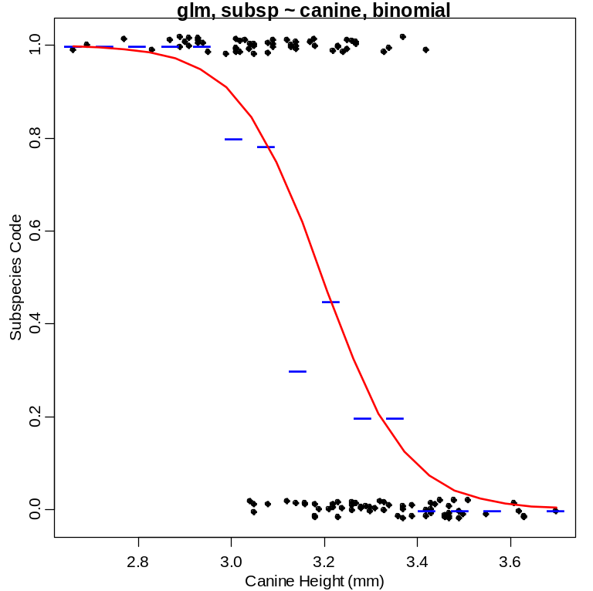

> Hosmer.Lem(glm1)
Hosmer-Lemeshow Goodness-of-Fit Test for Logistic Regression Model.
X^2= 7.682577 Df= 8 P(>Chi)= 0.4650748

> coef(glm1)
(Intercept) canine
35.51574 -11.11193

> confint(glm1)
2.5 % 97.5 %
(Intercept) 24.21618 49.662954
canine -15.52481 -7.589218

> predict(glm1,data.frame(canine=c(3,4)))
1 2
2.179940 -8.931994
> -8.931884-2.179940
[1] -11.11182
> exp(coef(glm1))
(Intercept) canine
2.656377e+15 1.493306e-05
> exp(predict(glm1,data.frame(canine=c(3,4))))
1 2
8.8457728416 0.0001320944
> 0.0001320944/8.8457728416
[1] 1.493305e-05

> summary(glm1)
Call: glm(formula = subsp ~ canine, family = binomial)

Coefficients:
Estimate Std. Error z value Pr(>|z|)
(Intercept) 35.516 6.428 5.525 3.29e-08 ***
canine -11.112 2.005 -5.543 2.97e-08 ***

(Dispersion parameter for binomial family taken to be 1)

Null deviance: 163.040 on 117 degrees of freedom
Residual deviance: 97.178 on 116 degrees of freedom
AIC: 101.18

Number of Fisher Scoring iterations: 5

> predict(glm1,data.frame(canine=c(3,3.4)))
1 2
2.179940 -2.264834

> predict(glm1,data.frame(canine=c(3,3.4)),type="response")
1 2
0.8984336 0.0940776

R Commands

library(NCStats)
bat <- read.table("batmorph.txt",head=T)
bat$canine <- bat1$canine*10 # convert to mm
attach(bat)
glm1 <- glm(subsp~canine,family=binomial)
plot.logreg(glm1,p.ints=15,xlab=”Canine Heigh”,ylab=”Subspecies Code”)
Hosmer.Lem(glm1)
coef(glm1)
confint(glm1)
predict(glm1,data.frame(canine=c(3,4)))
-8.931884-2.179940
exp(coef(glm1))
exp(predict(glm1,data.frame(canine=c(3,4))))
0.0001320944/8.8457728416
summary(glm1)
predict(glm1,data.frame(canine=c(3,3.4)))
predict(glm1,data.frame(canine=c(3,3.4)),type="response")

